1st March 2023

Revised Goods Book-in Scheduling Process Notice

Dear Partner,

As part of our ongoing continual improvement initiatives, I wish to advise you of important procedural changes relating to our warehouse book-in processes that will come into effect from 6th March 2023.

The enclosed guide below outlines our revised procedures including those relating to scheduling, documentation, health & safety, security and contact details. Please check the information carefully and cascade to the relevant parties within your organization to ensure a smooth delivery experience.

May I take this opportunity to thank you for your ongoing support and we believe these changes will benefit you and improve the overall efficiency of the experience. My colleagues and I look forward to continuing and further developing our business relationship and we welcome any feedback you may have once the new procedures are live, so that we can ensure the process is as smooth as possible.

Yours faithfully
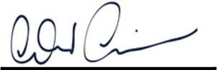
Andrew Grainger Operations Manager Exertis Ireland
Ireland Limited Directors: Rod McCarthy, Emer Breathnach, John Dunne, Mark Forbes, Tim Griffin, Stephen Casey, Damian Guerin, Fergal O’Dwyer, Gerry O’Keeffe.

Registered in Ireland 73204 VAT No: IE4559127E a Business.

Delivery Guide

Effective Date: 6th March 2023

Contents of delivery guide
- Introduction
- Scheduling your appointment

- Delivery punctuality

- Arriving at the distribution center

- Delivery documentation

- Criteria for delivery

- Presentation of stock

- Health & Safety

- Security

- Contact details.

Introduction

The logistics function within Exertis is responsible for the receipt and Despatch of products in a high-volume environment with a target to exceed all of our customers’ expectations.

As a supplier of products to Exertis it is important for you to understand our operational requirements in order that our business objectives are achieved.

These requirements will be mutually beneficial resulting in:

- Improved accuracy of booking in
- Reduced unloading time.
- Reduced queries; i.e. damages, short ships, etc.
- Earlier availability of products for sale to our customers
- Earlier payment of invoices to our suppliers
- Earlier re-ordering of products from our suppliers.

The purpose of this manual is to provide all our suppliers with clear and precise instructions of delivery expectations and service levels, which are becoming the standard throughout the industry.

We do not believe you will have any difficulty in meeting our expectations, however our Distribution Centre Goods Receiving Management team will be pleased to offer you guidance on any areas where your service levels to Exertis may be improved.

It is therefore imperative that the contents of this manual are communicated to, and understood by, all appropriate staff and personnel dealing with Exertis deliveries.

It is the supplier’s responsibility to ensure that any carrier making a delivery to Exertis is aware of and complies with these instructions.

Scheduling Your Appointment
All deliveries to Exertis must be as a result of a previously scheduled delivery appointment.

Your appointment can be made through our Exertis.ie booking in portal. Please refer to portal user document attached.

Amending booking times and dates:

If any delays are experienced and you cannot meet the delivery date/ time, please refer to the booking portal manual for options on editing your booking slot.

If you are late for your booking slot and have not advised Exertis you are at risk of:

  - Refusal.
  - long waiting times for next available slot.

Delivery Punctuality
In order to maintain the efﬁcient running of the Logistics Centre, all goods must be booked in with the Logistics Centre. Failure to adhere to this request may result in;
- Refusal of delivery
- Driver will have to wait for next available delivery time.

Exertis allows a 15 minute delivery window within which the vehicle is expected to arrive.

Vehicles that arrive at the Logistics center one or more hours prior to their allocated delivery time may be asked to arrive at the correct scheduled time or park away from the company premises.
This is dependent on:

- Workload
- Parking availability

We appreciate that in certain circumstances a vehicle can be delayed en-route. In such circumstances it would be mutually beneficial for the supplier or carrier to contact us and advise us of any expected delays. This can be done by updating the booking in portal.

This can either be by the supplier or the carrier / delivery driver.

If availability permits, we will accommodate the delivery, but in busy periods this may result in the vehicle waiting until the next slot or refusal of delivery. This could result in the goods having to be rebooked for another day and/or timed slot.

Arriving at the Logistics Centre

When the driver arrives at Exertis they must check in with Security at the Goods inwards entrance.

Driver must quote the Booking reference number that was issued at time of accepted requested booking slot through Exertis.ie.

Driver will be advised by Security as to which gate they will offload at and give any instructions required.

The driver will also be requested to present the delivery documentation to the clerk.

The Goods-In Team Leader will check the delivery documentation to ensure that the required criteria has been met.

Drivers should exercise caution when maneuvering their vehicle, taking into account Pedestrians and other vehicles moving around the distribution center.

Parking is not allowed on the site at any time apart from off-loading / loading or in the designated parking areas.

Attention should be paid to warning lights, Traffic lights and signs.

Loading Bay Doors are equipped with a pair of control lights, one red and one green. Do not offload if RED – vehicle is currently being worked on if GREEN – When work is completed, the vehicle may be moved when authorized to do so by the Goods-In personnel.
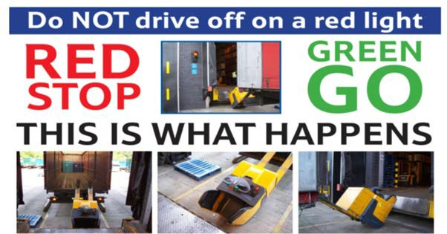

Delivery Documentation

Delivery documentation must include as a minimum:
- Supplier’s name
- Supplier’s address
- Contact name, telephone number, e-mail address.
- Purchase Order number (Exertis)
- Total units for each product line delivered
- Total number of units, cartons or pallets delivered.
- If a pallet of mixed product is included
- A pallet contents sheet
- Name of the carrier delivering goods

Goods that fail to have the correct paperwork applied and visible are at risk of being refused.

All delivery notes will be signed as unchecked. Delivery errors will be notiﬁed to the supplier within 48 hours of receipt.

All pallets must carry a full breakdown of the contents, including purchase order numbers, product type, quantity and barcodes.

Exertis receiving staff are targeted to minimize the waiting time of vehicles and to process deliveries within a timescale. Compliance with the above will assist with achieving this.

Criteria for Delivery

All deliveries will be signed for as UNCHECKED.

For UNCHECKED deliveries, a signature will be given for parcels or pallets but
NOT for the delivered quantity of goods.

Delivery vehicles must be able to accommodate powered pallet trucks with a minimum weight of 1,700kg plus pallet.

Note - All vehicles must be able to be unloaded via their rear doors

Any deliveries requiring special unloading equipment or action should be advised at time of booking the request.

Failure to disclose any salient points may result in a delay in off-loading the delivery.

Vehicles arriving that require the off-loading of non-Exertis stock will be refused as we are not insured to handle stock belonging to somebody else.

Exertis will accept no responsibility or liability for goods or equipment which have to be removed to enable access to Exertis product. This may also incur a cost or time delay.

Presentation of Stock
All palletized goods should be delivered on euro pallets 1200 x 800.
No pallet should exceed 1600mm in height (incl pallet) or weigh more than 650kgs.

Stock must NOT overhang on the pallet.
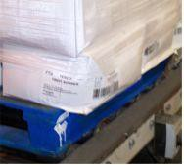
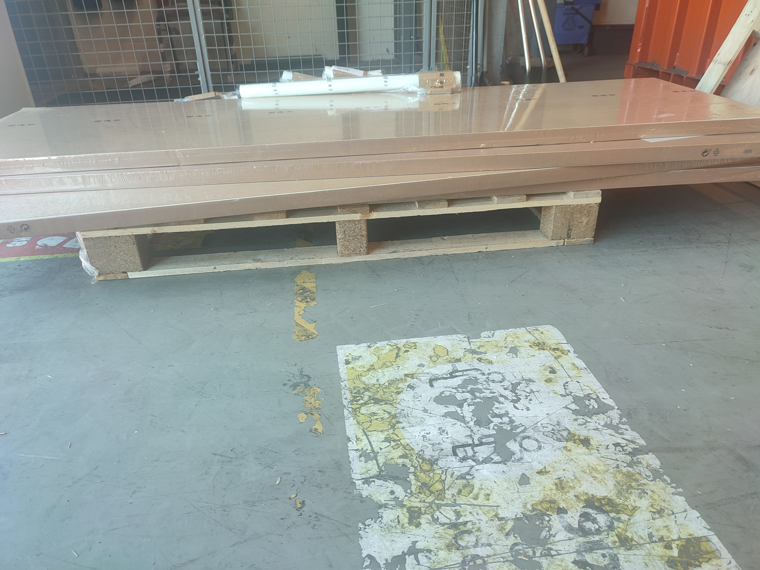

Pallets must be secured by the use of clear shrink wrap or stretch wrap only. This is for the ease of counting and also for checking damages etc. The wrap must be attached to one block of the pallet, securely wrapped & cover entire load.
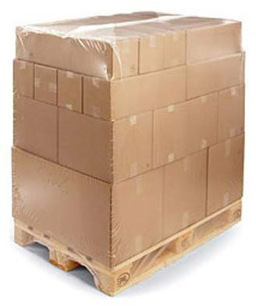
Ideally, pallets should only contain one product line. If this is not possible, a physical separator between the products is required.
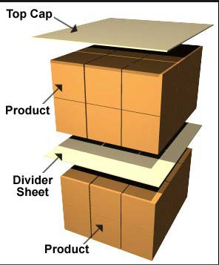

If the Pallet is mixed it should be clearly labelled with a "Mixed Pallet" Label and the contents list for this pallet also attached.
Any mixed pallets must only contain one PO number.
Each product must be placed separately in each corner of any mixed pallet.
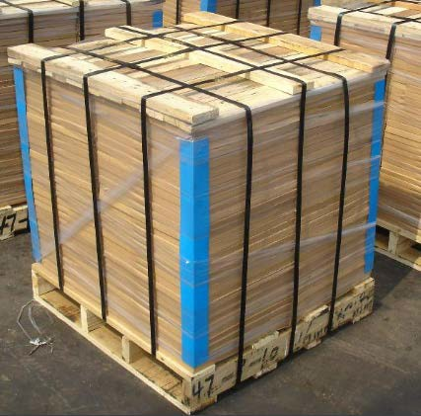
No Banded pallets will be accepted.
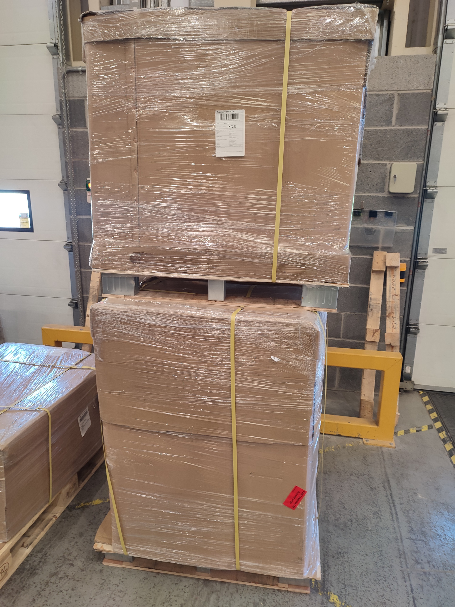
Pallets must not be double stacked, Unless by prior agreement

Cartons should only contain one product line per carton and must be marked with the product name, quantity, and bar-code to a minimum of 1 side and 1 end.

All cartons must be security sealed on arrival. Open pallets or cartons will be signed for as damaged with the possibility of shortage.

Pallets and cartons received not as specified may result in the delivery being cancelled or charges levied to the supplier.

Pallet standards

All pallets are to be of a strong construction without broken, cracked, missing or damaged slats. The corner blocks of the pallets must be fully intact.

All pallets provided should conform to the standards detailed here. Unfortunately, we cannot accept any pallets used outside of these standards.

Carton deliveries
Large quantities of cartons are received at the Distribution Centre daily.

Lack of identification on the cartons can lead to considerable delays in the receiving process.

Similarly, too much information i.e., carrier labels etc., can slow down the receiving process.

It is requested that the following guidelines are adhered to wherever possible:

- Each carton must contain only one SKU
- Each carton must be labelled with the Supplier Part Number and the Quantity contained in the carton
- The Purchase Order number that the product is delivered against
- Any cartons in excess of 24kg must be clearly labelled on two adjacent vertical sides of the carton in characters at least 25mm in height
- Where a carton weighs in excess of 5kg, the gross weight in kg must be stated on the carton
- It is stressed that cartons containing mixed product codes will not be accepted unless previously agreed with the Goods Receiving Manager

Product labelling & Bar coding

Presentation of Stock

Exertis Ireland Ltd requires that every product be clearly marked with the supplier part number and bar-code for each single unit.

In the case of a “re-pack” product i.e. 1 carton of 100 cables, all 100 cables must display a supplier part number. It is not acceptable to label the outer carton only.

Exertis Ireland Ltd also requires that every product is bar-coded.

Both EAN 39 and EAN 128 specifications are acceptable and the bar-code should be unique to the individual supplier part number and should be consistent with each subsequent delivery.

All bar-codes should be of good quality and should be easily read by a hand- held scanner and should not cover any serial numbers on the product.

NOTE:

Products that are delivered without the above will be subject to refusal or return to vendor (where this commercial agreement exists) via our RMA process.

New Lines are an important part of the sales performance of Exertis Ireland Ltd and any delays in the setting up of these, due to inaccurate data being presented can adversely affect this performance.

Before the first delivery the following must be provided for each new line:

- The product description
- The supplier’s product code
- Dimensions, height, depth and width of the case and the single, and the orientation the product will be stacked on the pallet
- The weight of the single in kg
- The number of single items in a case, layer and pallet
- Quantity of cases that will be stacked per layer.
- Quantity of layers per pallet
- Bar code details
- Hazardous product details if applicable, include materials data sheet.

New Product Lines
An initial check of the delivery will be made at point of receipt for carton and pallet quantities and deliveries will be signed for ‘unchecked for quality,
quantity and weight.’

A subsequent detailed check will take place and discrepancies will be notified through GRN receiving admin, or through the purchasing department in line with current agreements at the time.

Products for return i.e. miss-ships, damage etc., once an RMA number has been issued, it is the responsibility of the supplier to arrange collection from Exertis Ireland Ltd within five working days.

If the products are not collected within this time scale Exertis Ireland Ltd will arrange for a carrier to return the products and the supplier will be invoiced for the cost of carriage.
Any closure due to public or bank holidays or for other reasons must be notified to the relevant buyer at least two months in advance, who will as required ensure our suppliers are aware.

Post Delivery Procedure

Opening Times: 8am to 16.00pm
A Delivery appointment is required for any Return consisting of one pallet or greater than ten cartons. Small volume deliveries i.e., couriers do not require a booking slot.
All delivery appointments (bookings) must be made via our Customer Service Department a minimum of 48 hours in advance of the proposed delivery date to ensure the relevant RMA numbers and vehicle details have arranged for the collection and delivery.
In addition the customer/carrier is required to contact the Returns department for deliveries consisting of two pallets or greater.
The carrier will be asked to supply: Valid RMA number/D Note No./Date and Time of delivery.
*Valid RMA – is defined by an RMA that is not cancelled, closed or entered.

Returns – Pallet (and large Carton deliveries)
It is stressed that any delivery arriving without delivery notes or a clear RMA on the pallet/carton will be subject to a considerable delay or refusal.
The minimal detail of a delivery note must include:
- All RNA numbers applicable to the delivery contents.
- The delivery address and reference.
- A manifest of the items delivered.
- The total number of each part number delivered.
- The total number of pallets delivered.
- The total number of cartons delivered.
- The customer’s name & address.

Returns Department
The Documentation should be clearly displayed on the outside of the shrink wrap or carton.
Pallets must be securely wrapped with shrink wrap so that the contents of the pallet are protected from tampering.
The goods should be secured such that the pallet contents cannot shift during transit.
The contents of all cartons should be securely sealed within and packaged sufficiently to avoid damage.
NOTE: It is stressed that any delivery regarded as unsafe or presenting a hazard to receiving staff will be refused by the receiving Manager.

Returns – Pallet (and large Carton deliveries)

Large quantities of cartons are received at the Logistics Centre daily.
Lack of identification on the cartons can lead to considerable delays in the receiving process.
Each Carton must be labelled with the RMA Number corresponding to the box contents. It is stressed that any delivery arriving without an RMA will be subject to a considerable delay or refusal.
Carriers who handle refused deliveries must make provision to display information relevant to the returned goods contained.
This must be agreed upon by a senior representative of both the customer/carrier and Exertis Ireland Ltd.
Cartons failing to display the agreed level of information will be subject to a considerable delay or refusal.
All deliveries must be securely packaged inside a box with adequate packaging.

NOTE:
Unless informed otherwise all returns deliveries coming into our site will come through our Goods receiving Department doors.

Health & Safety
Drivers delivering to the distribution center must wear Hi-Vis jackets at all times.

Children and pets are not allowed within the Logistics Centre. Drivers must wear safety shoes or boots.

We operate a designated smoking area policy, and this must be adhered to. Drivers are not permitted to enter the Logistics Centre.
Vehicle ﬂoors must be structurally sound and be able to withstand the entry of
Powered pallet trucks that have a minimum weight of 1700KG plus the pallet.

The maximum weight of products on a pallet must not exceed 650kg. Pallets must not be double stacked.

Drivers must have a comprehensive understanding of English, to ensure they can be communicated with and any issues reported.

For health and safety reasons, drivers are required to surrender their vehicle keys prior to loading/unloading. They will be returned with the relevant paperwork when complete.

Passengers in vehicles may use the site services at the discretion of the Goods-In team
Leader.

Note:

It is stressed that any delivery regarded as unsafe or presenting a hazard to receiving
Staff, Will be refused by the Goods-In team leader.

Security

Drivers are not permitted to enter the Logistics Centre without the express permission and instruction of the Good-In supervisor.

No unauthorized personnel or animals are permitted on site.

Both drivers and vehicles are liable to be searched whilst on site. As such drivers are expected to comply when requested.

Sealed vehicles must be opened by a member of the Logistics Centre. Vehicles that are not sealed will be reported as so.

Drivers must leave the site immediately after unloading.

Drivers are not permitted to have their break time or drivers rest period on the premises.

We operate 24/7 CCTV at our site to ensure safety and security procedures are adhered to at all times.

Contact details:

PH: 0873597556

Goods In Operating Hours: 07:00 – 14:00 (Mon-Fri)

Distribution Centre Address:
Exertis Ireland Unit 21,
Fonthill Business Park, Fonthill Rd,
Co. Dublin D22 FR82

